Doc Writer: Pavan y Doc Date: Dec 08, 2015.

Application or System Name
ENROLLMENT PROCESSES
General Overview
Ability to identify previous DPP customer at time of Move In and prompt Enrollment initiation.
An enhancement will present iFactor preference center information to CE Users as part of the DPP Enrollment process, necessitating the addition or update of preferences as needed.
The CE user would have to remember themselves to initiate DPP Enrollment request for the customer, manually investigate to identify if the account is considered eligible for DPP Enrollment.
Additionally, the CE user would have to remember to navigate to the Preference Center in CRM after the completion of a Move In, and update a mandatory preference for the DPP Enrollment.
By implementing these changes, the system will perform an automated basic validation (like Residential customer, Electric Service, and over the air Meter Reading capability) behind the scenes after the completion of a Move In. If the basic checks are successful, the system will display message on email collection screen.
An enhancement is needed in CRM to add functionality to the end of the Move In process to perform a basic check (like Residential customer, Electric Service, and over the air Meter Reading capability) to determine whether or not to prompt the user to access the customer programs Enrollment Center. If the account passes these eligibility checks, a message will be displayed to the Email Collect view
Technical Design:
Function Modules:

ENHANCEMENT DESIGN SPECIFICATIONS:
Enhancement Requirements
Number | Description of Requirement
1 | Creation of new Function Module to check the basic eligibility for Residential Customer, Electric Service and Over the air Meter Reading Capability.
2 | Creation of System Message in CRM prompting Customer Program Enrollment and Navigation to Enrollment Center.
3 | Creation of logic to see if DPP program was selected for Enrollment in the Enrollment Center, navigate the user to the CE Preference Center

Go to Component work bench bsp_wd_cmpwb, here we have to create a new component and the component name is ZDPP_ENROLLMENT.
In this go to runtime repository it consist of a main window and enrollment view set and in enrollment view set we have view areas.
Enrollment view consist of check box and a 2 buttons. Eligibility check it’s a standalone.
In component structure browser we can see windows and views
Go to windows->ZDPP_ENROLLMENT/Mainwindow
In the process enrollment Go to the method Inbound Plugs->IP_ENROLL_CPP

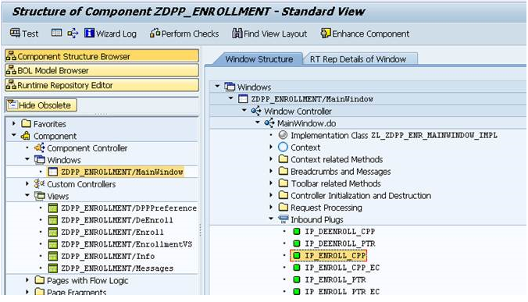

Go to Method-> Process_input
method IP_ENROLL_CPP.
* Process CPP Enrollment
CALL METHOD process_input
EXPORTING
iv_zpgmtype = 'CPP'
iv_zenrl_type = '1'.
endmethod.
Here we will call the method PRECHECK it will checks for the confirmation from the customer and get the confirmed business agreement.
Then perform back to identification here also we are calling the method NAV_TO_IDENT it will checks for error and get the navigation reference and navigate to the identification.
Call the method SHOW_MESSAGE. In method Check_eligibility it will set the input and get the RFC destination.
It will call the BRF Plus and perform the Eligibility Checks by calling the function module ZPGM_ELIGIBILITY_CHECKS.
Then navigate to enrollment view finally set the enrollment data.

In the identification screen we will see all the enrollments in PTR Enrollment process when we click on customer contact detail screen here we have to maintain an E-mail Address, otherwise it will show an error message.
When we maintain an E-mail address and click on next actually enrollment process creates an entry in the table and sends an outbound and it will take to the next enroll view DPP preference View.
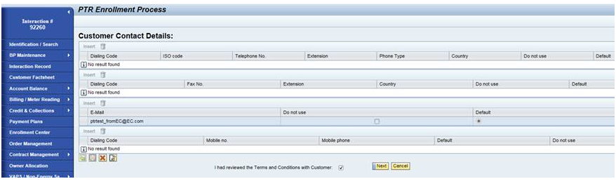

Again go to the Component work bench bsp_wd_cmpwb, and the component name is ZDPP_ENROLLMENT.
In this go to Component Structure Browser-> views-> ZDPP_ENROLLMENT/Enroll-> View Structure-> Event Handler->EH_ONSUBMIT

Go to Method EH_ONSUBMIT it will check Business partner checks for the errors and then it will validate for the E-mail Address and finally it process enrollment finally shows the message.

Go to the transaction code GENIL_MODEL_BROWSER.
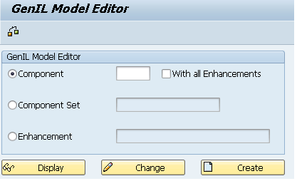
In the above Genil Model Editor and the Component is ZENROL

Here we can see the Model objects-> Root Objects->Root Objects Enrollment.

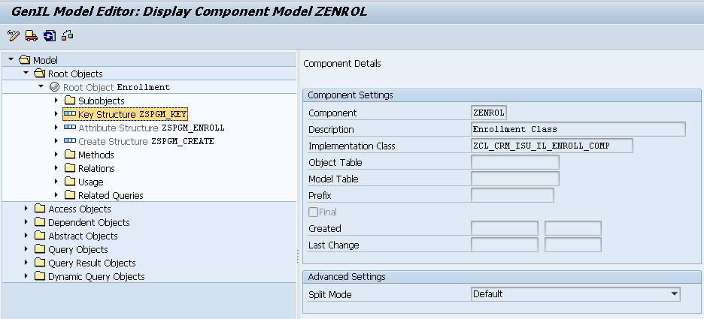

In this we can see key structure ZSPGM_KEY in this structure we can see enrollment business partner number, Enrollment contract account number, Enrollment program type and Enrollment requested date.
Also we can see the attribute structure ZSPGM_ENROLL it Consist of all the program enrollment structure
Create Structure ZSPGM_CREATE we can see the components as enrollment business partner number, Enrollment contract account number, Enrollment program type, Enrollment requested date and Enrollment service delivery point ID.

Go to the transaction SE24 is a class builder ZCL_CRM_ISU_IL_ENROLL.
Here go to the method->IF_CRM_IU_IL_ABSTR_ROOT~CREATE in this ZISU_IL_ENROLL_CREATE is a function module in this function module we are creating a function group ZCRM_PGMENROLLMENT in this Function Group we can see some function modules consist of all the function knowledge for create enrollment like Create Save which is used create a customer It will create an object checks for the order exists in the app buffer it will the entries in the enrollment table if no error exists and then send the confirmation to EV.

System Diagram
Technical Parts Inventory
-------Name------- | ----Description---- | -----Location----- | ----Environment---
ZDPP_ENROLLMENT | Component |  | C3D
ZCL_CRM_ISU_IL_ENROLL | Class |  | C3D
ZISU_IL_ENROLL_CREATE | Function Module |  | E2D

Dependent Parts Inventory
-------Name------- | ----Description--- | -----Location----- | ----Environment---
N/A | N/A | N/A | N/A

